Action Research

John Sandars
Action Research: Practice based learning

Issues
- Research is a minority activity in general practice

What Is Action Research
- A method of doing research and solving a problem at the same time with the aim of providing the most effective and efficient health care
  - eg Would a 3 day course of trimethoprim for cystitis be just as effective as a 7-day course?
- It is more about improving practice rather than improving knowledge

Elliot, Book, Open University Press, 1991
Action research for educational change

- It is a very good way of Practice Based Learning
- It is PGEA accreditable
- It is not the same as audit
  - Audit involves standard setting and evaluating to see if has been met
  - Action research is about a critical enquiry: will the change enable us to act differently

How Is It Done
• 3 stages
ENQUIRY the question you ask (a real clinical issue)
it needs to be realistic and achievable
ACTION the action you wish to investigate
PURPOSE mainly to improve health care (+knowledge)

The Action Research Project Cycle
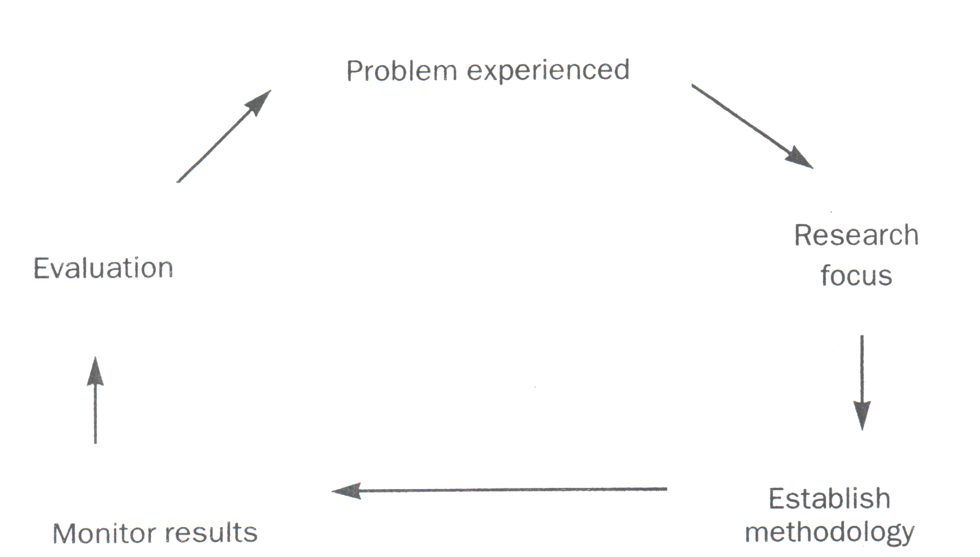
Research Focus: ‘What am I trying to do’
Make sure it is not too complicated
Make sure it is relevant to the needs of practice/patients
Aim is NOT a publication in a research journal! but rather to improve care

Methodology: Background reading (what have others done, how did they approach it etc)
You may need to improve your skills in areas like questionnaire design & data handling

Evaluation: what did you find, is it surprising?
what have you learnt then?
how can this learning be applied?

Remember ethics
- Make sure that the rights of the patients are respected
- Assess risk/benefits before the project starts
- if you are worried about ethical implications, contact local research ethics committee

Advantages
- A form of Problem Based Learning
- Lends itself well to a multidisciplinary approach
- Promotes your research skills
  - as well as a variety of other skills
- Useful When No available evidence on your dilemma
  - Many of the questions we ask are unique to our own practice, so there are no published answers available.
- You are more likely to weigh up the evidence
  - and hence integrate it into your day to day practice
- Benefits Practice & patients

